**Birla Institute of Technology & Science, Pilani**

**Work Integrated Learning Programmes Division**

**Third Semester 2020-2021**

**Assignment 1**

Course No. : S2-20_DSECLZG522

Course Title : Big Data Systems

Using Hadoop for Historical Sales Data Analysis

# Contribution & Team

**Group 079**

|  |  |  |
| --- | --- | --- |
| S.No | Name | BITSIDNO |
| 1 | Yashodeep Vaidya | 2019HC04042 |
| 2 | Sharad K Laad | 2019HC04034 |
| 3 | Vijay Jaiswal | 2019HC04049 |

# Table of Contents

Contribution & Team 0

Table of Contents 1

Purpose of study – Assignment Details 2

Solution: 3

Question 1 & 3 3

Java Class Structure 3

Implementation Code 3

Command to Run the Driver 3

Taking User Input: Item Type 4

Running Logs: 4

Summary of MapRaduce Job: 4

Question 2 6

Java Class Structure 6

Implementation Code 6

Command to Run the Driver 6

Taking User Input: Item Type 7

Running Logs: 7

Summary of MapRaduce Job: 7

Question 4 9

Java Class Structure 9

Implementation Code 9

Command to Run the Driver 9

Taking User Input: Year 10

Running Logs: 10

Summary of MapRaduce Job: 10

# Purpose of study – Assignment Details

Purpose of this report and study is to answer following questions

**Business context:**

A large multi-national retail chain has sales orders data across regions and different sales channels for a large variety of item types. The business team wants to use this data to analyze various aspects of sales - e.g. top selling items in a region, regions with maximum profit in a certain item type, if there is a significant difference in revenue in two item types across regions etc.

**Problem statement:**

As the data analytics team, use the sales transaction data set with about 100K records to answer these questions below —

1. Average unit_price by country for a given item type in a certain year
2. Total units_sold by year for a given country and a given item type
3. Find the max and min units_sold in any order for each year by country for a given item type. Use a custom partitioner class instead of default hash based.
4. What are the top 10 order id for a given year by the total_profit

You have to show the above analysis working on a Hadoop system using map reduce code, preferably in Java or Python. You can do data preparation steps as required before running a MapReduce job to answer these questions above.

**Submission materials:**

* Working documented code

Data set:

[https://drive.google.com/drive/folders/1fJyk6GE13xw0P-OKWwW8fxa-ny1G0TPp?usp=sharing](https://drive.google.com/drive/folders/1fjyk6ge13xw0p-okwww8fxa-ny1g0tpp?usp=sharing)

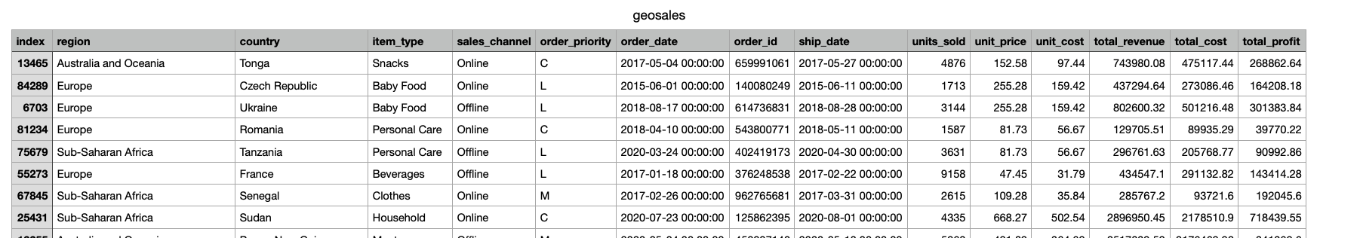

# Solution:

## Question 1 & 3

1. Average unit_price by country for a given item type in a certain year
2. Find the max and min units_sold in any order for each year by country for a given item type. Use a custom partitioner class instead of default hash based.

**Answer 1&3:**

Since the input and parameter were same for Q1 and Q3 we have used same implementation for both.

### Java Class Structure

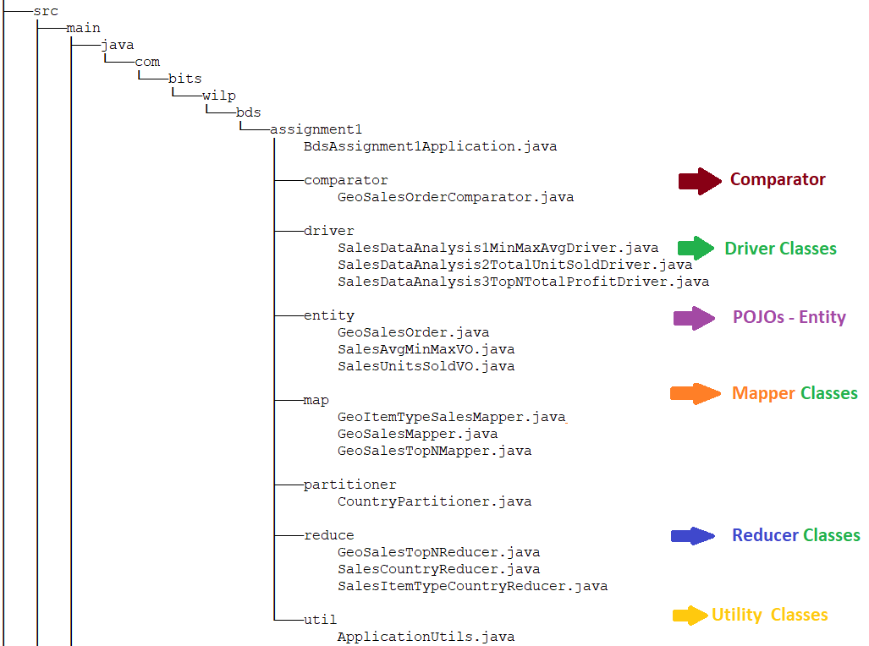

### Implementation Code

Attached with this document.

### Command to Run the Driver

***java com.bits.wilp.bds.assignment1.driver.SalesDataAnalysis1MinMaxAvgDriver geosales.csv geosales_output_1***

Here :

1. **geosales.csv:** input file having historical sales data
2. **geosales_output_1:** Output folder where the analysis results will be saved

### Taking User Input: Item Type

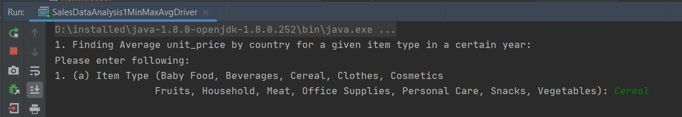

### Running Logs:

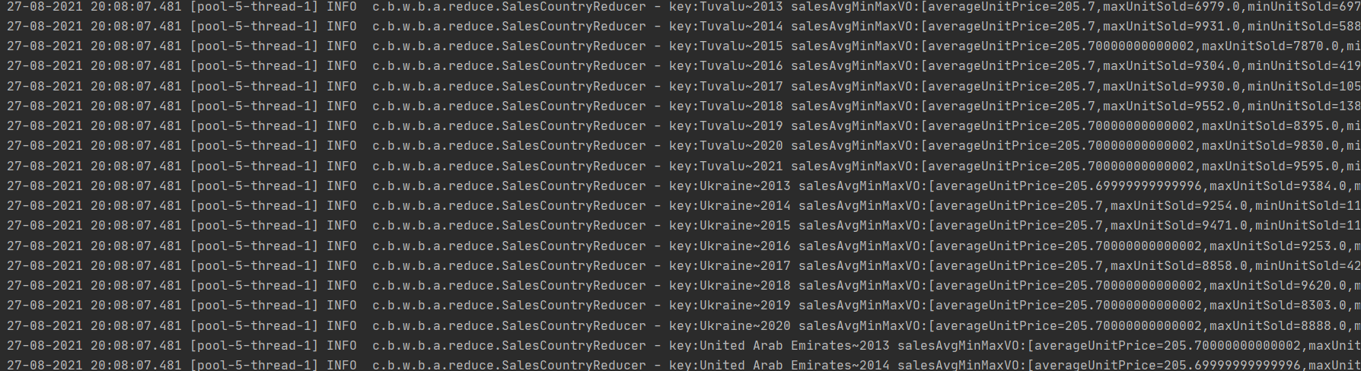

### Summary of MapRaduce Job:

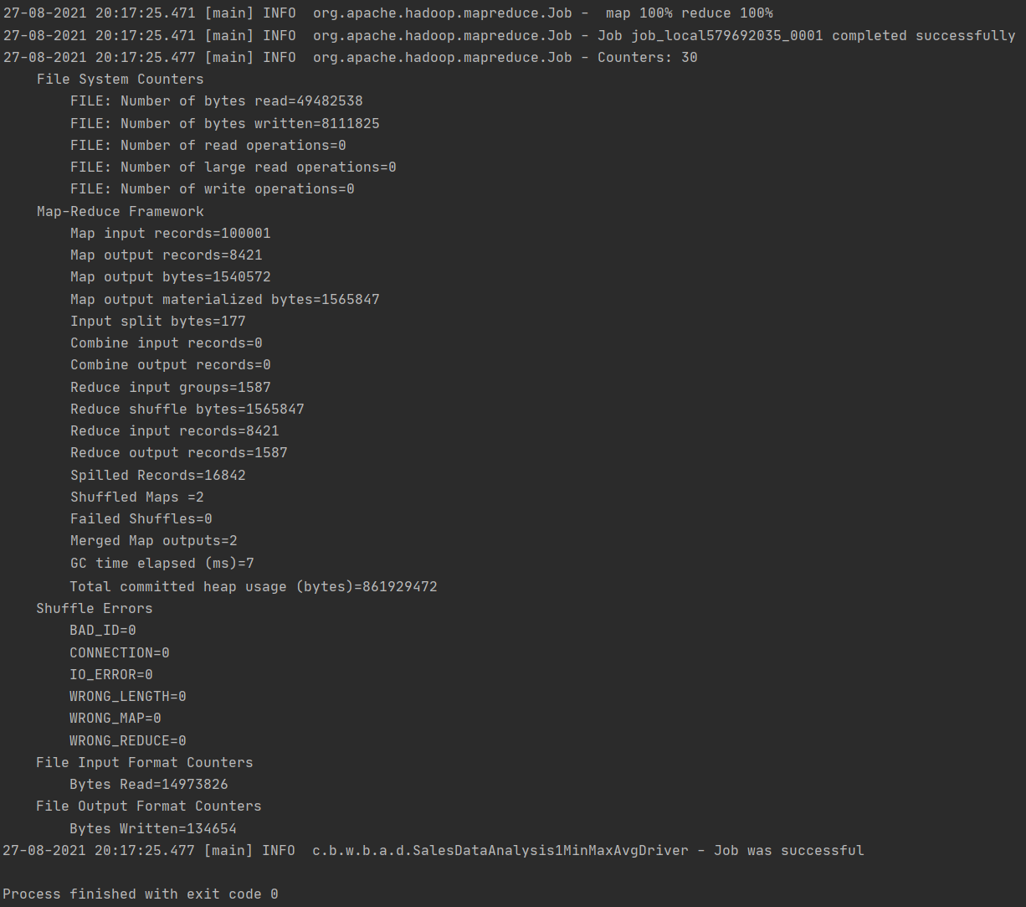

Output Folder Created with Analysis: 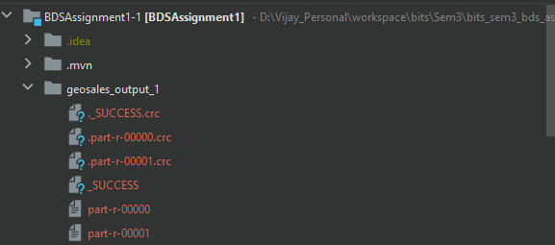

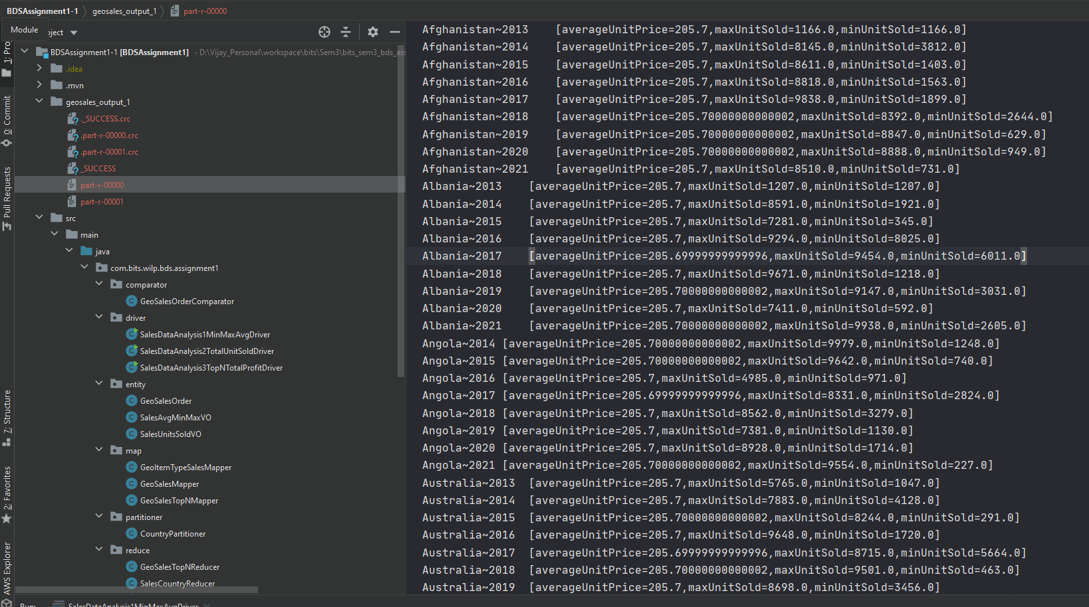

## Question 2

1. Total units_sold by year for a given country and a given item type

**Answer 2:**

### Java Class Structure



### Implementation Code

Attached with this document.

### Command to Run the Driver

***java com.bits.wilp.bds.assignment1.driver.SalesDataAnalysis2TotalUnitSoldDriver geosales.csv geosales_output_2***

Here :

1. **geosales.csv:** input file having historical sales data
2. **geosales_output_2:** Output folder where the analysis results will be saved

### Taking User Input: Item Type

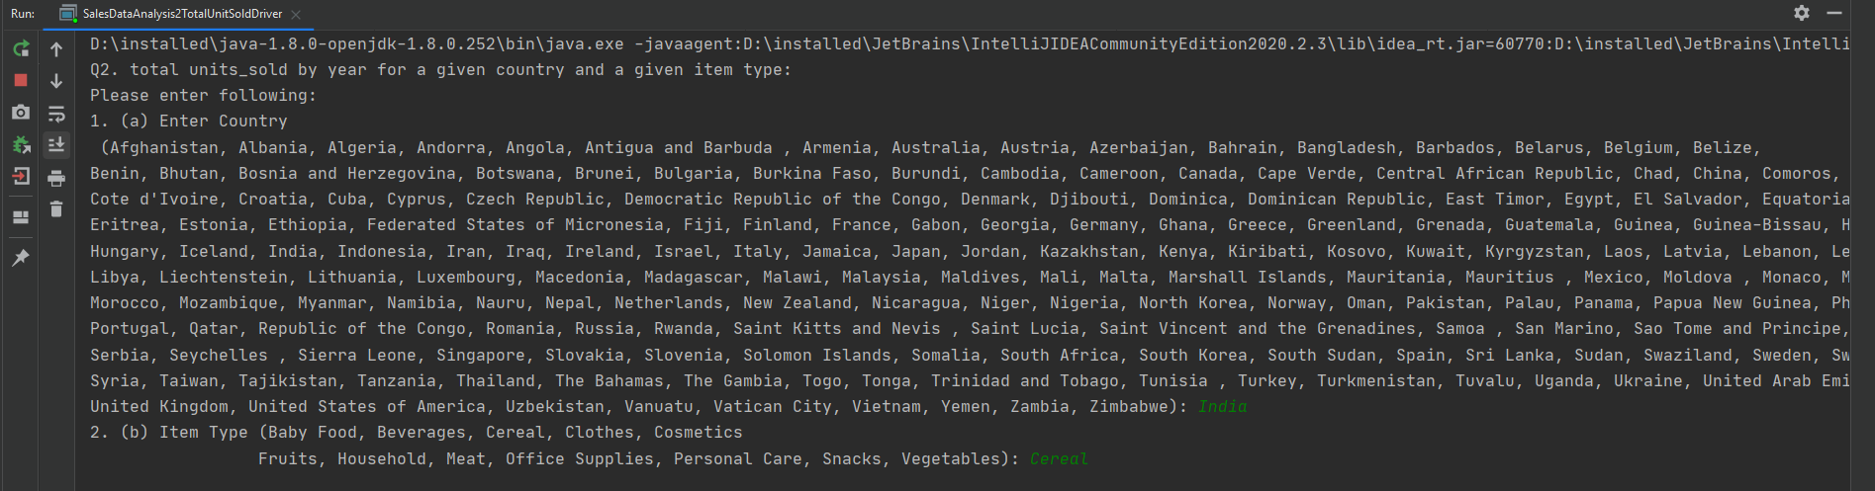

### Running Logs:

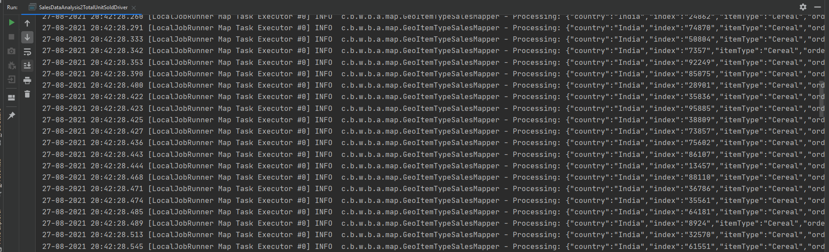

### Summary of MapRaduce Job:

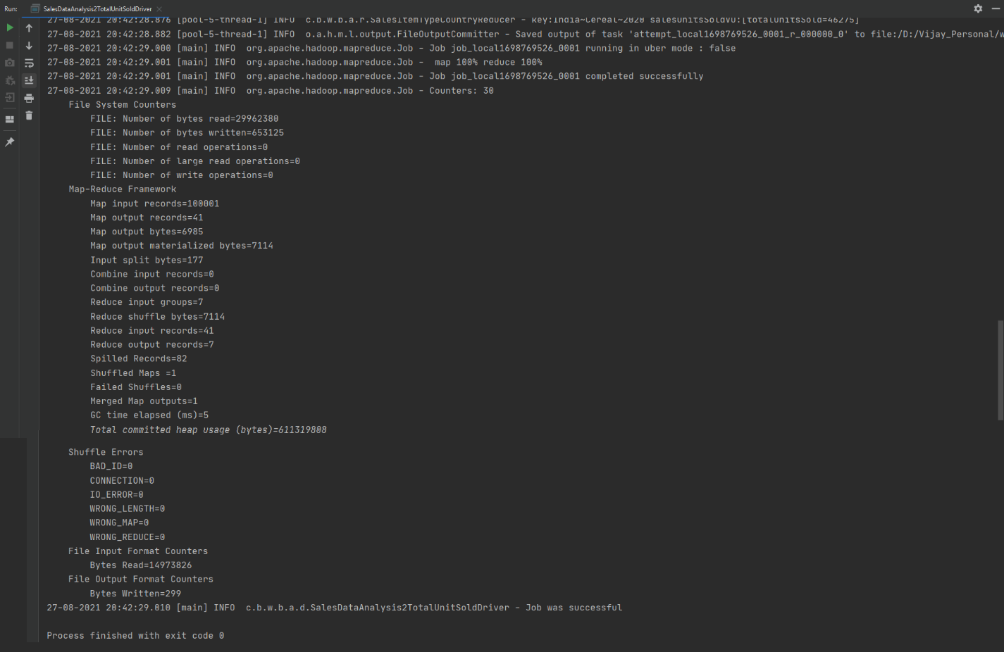

Output Folder Created with Analysis: 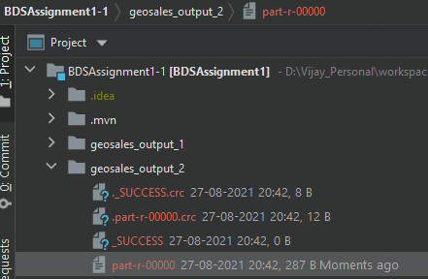

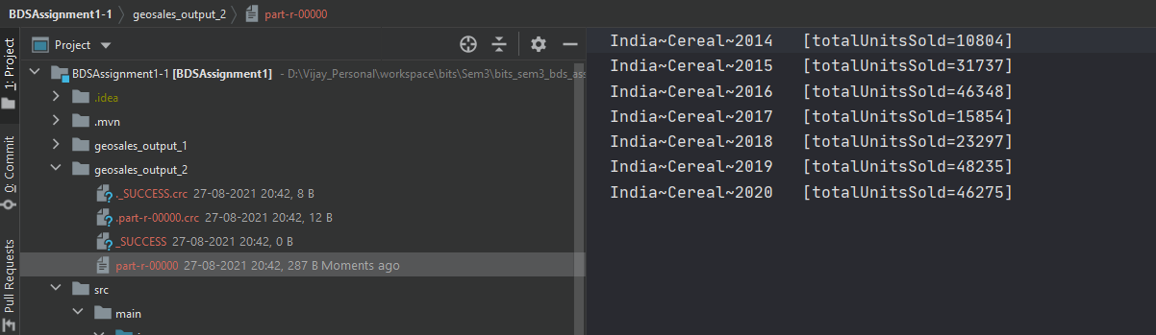

## Question 4

1. What are the top 10 order id for a given year by the total_profit

**Answer 4:**

### Java Class Structure



### Implementation Code

Attached with this document.

### Command to Run the Driver

***java com.bits.wilp.bds.assignment1.driver.SalesDataAnalysis3TopNTotalProfitDriver geosales.csv geosales_output_3***

Here :

1. **geosales.csv:** input file having historical sales data
2. **geosales_output_3:** Output folder where the analysis results will be saved

### Taking User Input: Year

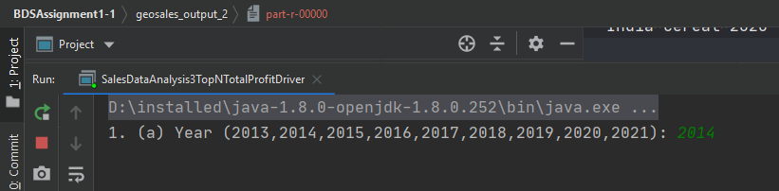

### Running Logs:

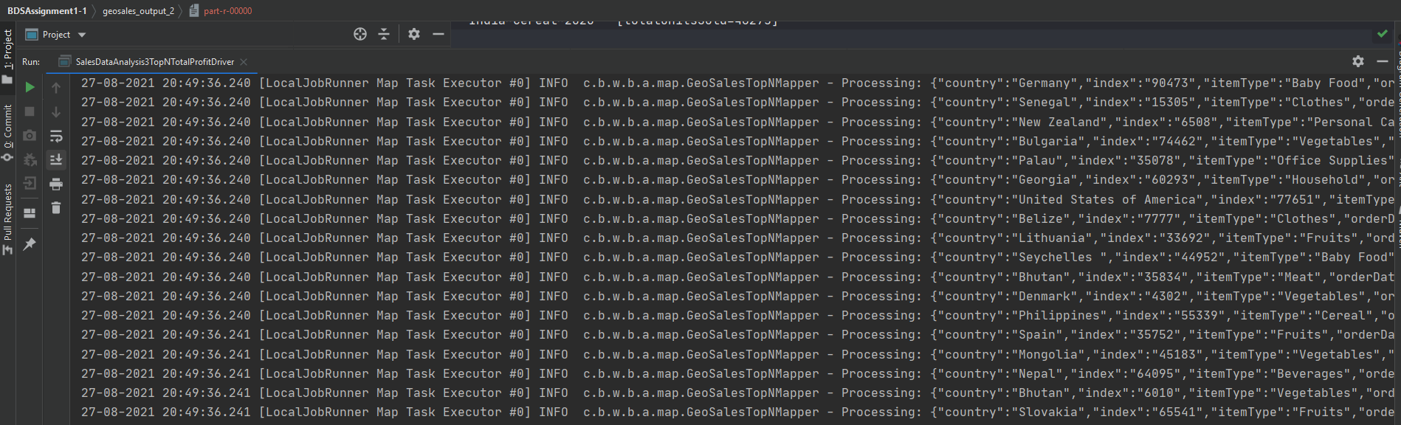

### Summary of MapRaduce Job:

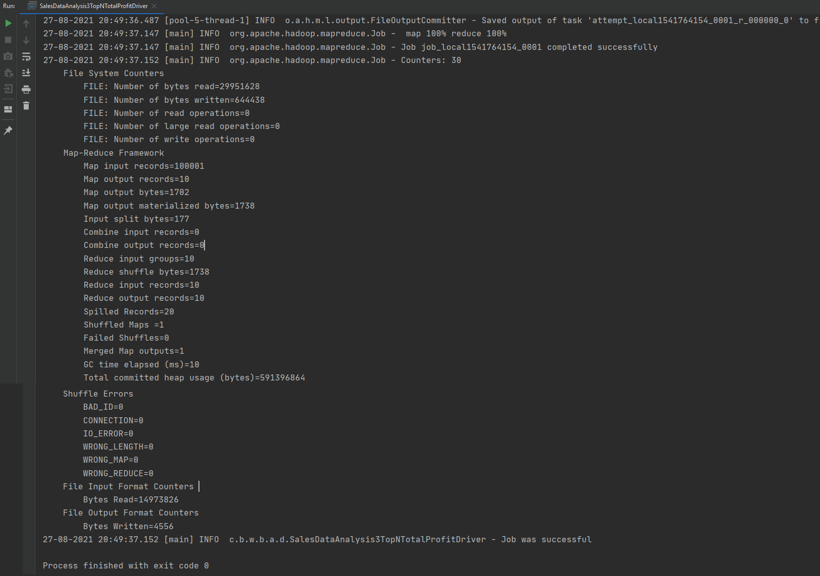

Output Folder Created with Analysis: 